

**Understanding and caring for blind or seeing impaired Cats**

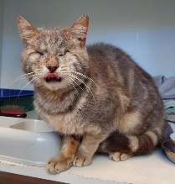

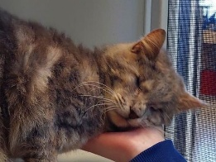Blind cats, cats with one eye, or those with limited vision are amazing. You might not think so, but they live life very much like their seeing friends. All it takes is a bit of patience, consistent routines, extra enrichment, and some small amendments on your part to help them thrive, and in time, you’ll barely notice their limitations.

If you adopt a blind kitten or very young cat they will adapt more quickly to your home.

Blind cats rely on their memory and make a mind-map of their environment/home. They also rely heavily on their senses, particularly hearing and smell. They can hear sounds at a distance and leave a scent/pheromone trail to follow using the scent glands on their paws and cheeks. They use their whiskers to judge distances, detect objects and obstacles which enables them to navigate familiar spaces with ease.

**How to care for a blind cat**

* Cats with limited vision are slower to react so they can’t get away from danger quickly. This means **they must be kept indoors** where they can learn what’s around them which makes them feel more secure
* It’s very important to start a blind cat off in their own ‘safe room’ - a small area which has everything they need including a scratching post, toys, litter, food and water bowls. Make sure they are comfortable here first before allowing them into larger areas of the house which they don’t know
* 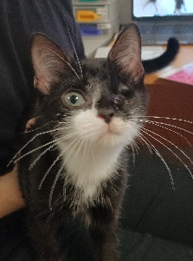Keep food and water bowls, litter boxes, and bedding **in the same location**
* Generally speaking the space they live in should not be cluttered and there must be clear pathways to other areas. Furniture and other items should be **left in the same place** and not re-arranged as they could easily bump into things and become disoriented &/or hurt. Rugs help to change the texture of the floor which gives them clues to navigate
* If you have stairs, put up a barrier, like a child’s stair gate, until your cat knows where they are and learns how to use them
* Just like other cats, blind cats like to play, so keep things interesting with toys and puzzle feeders to stop them getting bored. Bells, squeakers, crinkly balls and hanging toys which make a noise when touched are good and items with new smells or differently textured surfaces will encourage them to play and develop hunting instincts. Google ‘sensory toys for blind cats’ for ideas. You can make a ramp so they can climb the scratching post/cat tree and cover the levels with different textures so they know how far they are from the floor
* Avoid carrying these cats around – if you carry them from one room to the next or lift them onto a couch or other raised surface, they may become disorientated and even fall. To gain their bearings and leave their scent they need to walk between things. If you do happen to pick them up, place them back on something they will recognise, like the litterbox or something that has a different texture
* Always speak softly when approaching your cat to avoid startling them, use your voice to let them know where you are and spend time talking gently so they get used to you using their name. If they seem disorientated, guide them back to a familiar place by using your voice
* Blind cats can get on with other cats but they must be introduced carefully. Many blind cats are **gentle and cautious**, which can actually help prevent conflict. Likewise, if the other sighted cat is **calm and not aggressive**, they are more likely to accept the blind cat easily. It’s important not to let a dominant or very playful sighted cat, bully the blind cat
* Add a bell to the collar of other cats or animals in the home so the blind cat can hear where they are



**The owner of a blind cat describes his experience**

My blind cat walks around almost perfectly fine. Looking at him, you can sense he isn't a "normal" cat, but he’s adapted so well that unless you look closely, you can't tell that he has no eyes.

With my guy, the biggest thing is consistency. Especially when I first got him, I made sure I left things on the floor in the same spots so he could mentally map out the area. Now that he's more used to his blindness, I can move things around, but I try not to, and if I do, I move one thing at a time

to make it easier for him. He's bonded with his sister and she wears a collar with bells so he knows where she is.

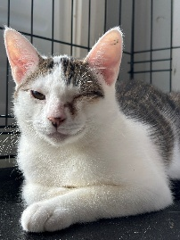

I try and keep his stress level/confusion down because when he gets scared, he whirls around in a circle to escape and is more likely to hit his head. He's sometimes bumped his head on table legs, etc. so I try and use different words or sounds to warn him if he's getting too close. When I approach, I make noises to let him know I'm coming, whether that's with my voice or tapping objects along the way. I also try not to pick him up because he can get confused when he’s in the air. But if I do pick him up, I always put him back down on something he will recognise.

My blind guy is the best fly-catcher out of all of my cats. He can be almost asleep on the couch, hear a fly and spring into action - he'll stalk it, catch it and eat it. He also comes when called because he’s used to my voice and knows his name. He LOVES crinkly things, like tinfoil and scrunched up paper. I have made a ramp so he can get up onto the cat tree and covered the upper levels with different material so that he can tell where he is.

Because he’s had his eyes removed, his eye ducts no longer drain or lubricate his nose properly so I use a humidifier to prevent it getting blocked.

Home-made hanging discs which

Make a noise when touched

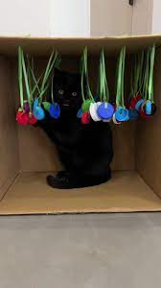  

Scrunched up ball of paper

References: Jackson Galaxy – 3 tips for living with a blind cat ttps://www.youtube.com/shorts/YbMncqM3ylA

Caterescue901

Purrfectly Imperfect - Caring for a blind cat https://www.youtube.com/watch?v=sy9m5hUv1z